Please complete these activities over the summer break. There will be an essay assigned during the first week of school in which you will be able to use all of the items you create.
Use this website as a resource. doerrtosuccess.weebly.com.
**************************************************************
Not many people know that Treasure Island was originally written in the magazine Young Folks over a period of several months from 1881 to 1882. Robert Louis Stevenson was trying to keep young boys interested in reading and aimed to provide them with a terrific adventure. Now, in 2017, many authors design an entire series of novels with the same intent – to keep adolescents interested in reading and to provide them with stories of adventure.

*READ one novel from a series AND Read TREASURE ISLAND.

****************************************************************************
1) Read Treasure Island by Robert Louis Stevenson. A copy was provided to you on June 1, 2017. You are welcome to buy your own copy as well.
2) Keep a journal of important quotes and events that will help you on the Day One Writing Assessment. (see questions below) Minimum of 5 quotes each.
3) Read ONE "series" novel to compare and contrast with Stevenson's.
Here are some suggestions – but you are not limited to this list.
House of Night by P.C. Cast The City of Bones by Cassandra Clare
Pretty Little Liars by Sara Shepard Harry Potter series by J. K. Rowling
The Ranger’s Apprentice by John Flanagan Gone series by Michael Grant
Fablehaven by Brandon Mull The Maze Runner series by James Dashner
A Series of Unfortunate Events by Lemony Snicket The Apothecary series by Maile Maloy
The Last Apprentice by Joseph Delaney The Penderwicks series by Jeanne Birdsall
4) Keep a journal of important quotes and events that will help you on the Day One Writing Assessment. (see questions below) Minimum of 5 quotes each.
5) Create a Thinking Map to record textual evidence for EACH of your novels.
a) What techniques are used to keep a young reader interested?
b) What lessons about growing up are being taught in these novels?
c) How is word choices similar and different?

While you are reading, continually record pages and events in your journal that will support your answers to these 3 questions regarding the writing format of the books.

**When you return to Pau Wa Lu Middle School, you will write an essay using your thinking map and your personal journals. ALL Work must be completed PRIOR to first day of school.**

Treasure Island (Unabridged): 1100 Lexile -- 12 AR points –
It is also available on the public domain, so feel free to download the audio.

Douglas County Public Library is a great resource for finding series novels.
Consider used bookstores and yard sales as well!

doerrtosuccess.weebly.com -- (website)
Text @8adveng to the number 81010 (remind)

*You will be able to take the AR test on Treasure Island AND your independent reading book when you return to school in the fall to help you earn your required number of AR points. 75 points required for each semester of Advanced English.*
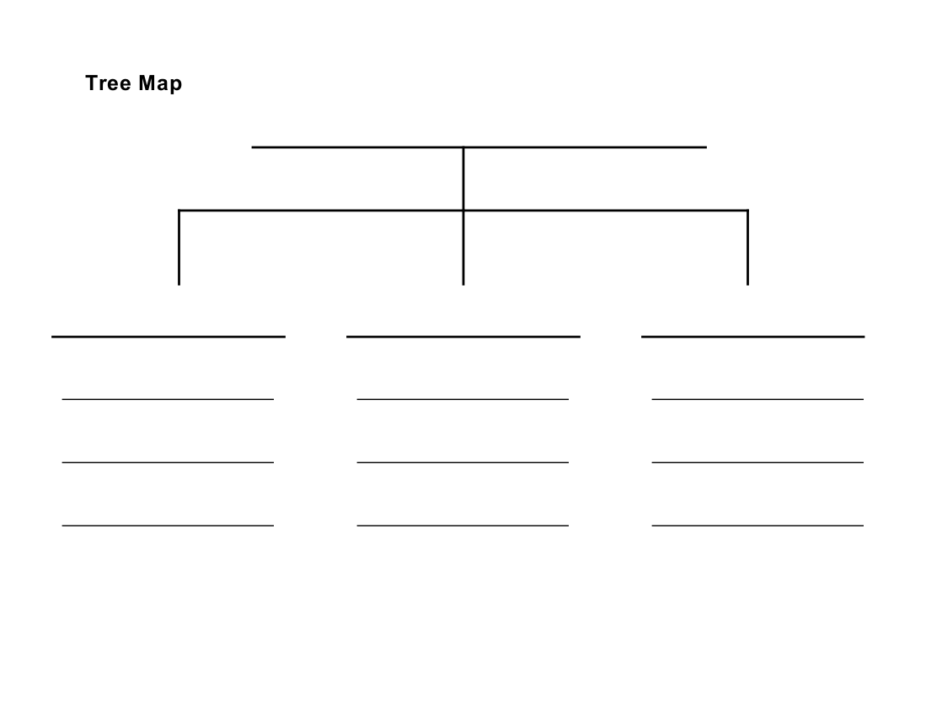
word choice – examples & reactions
lessons about growing up
techniques to keep readers interested
Treasure Island
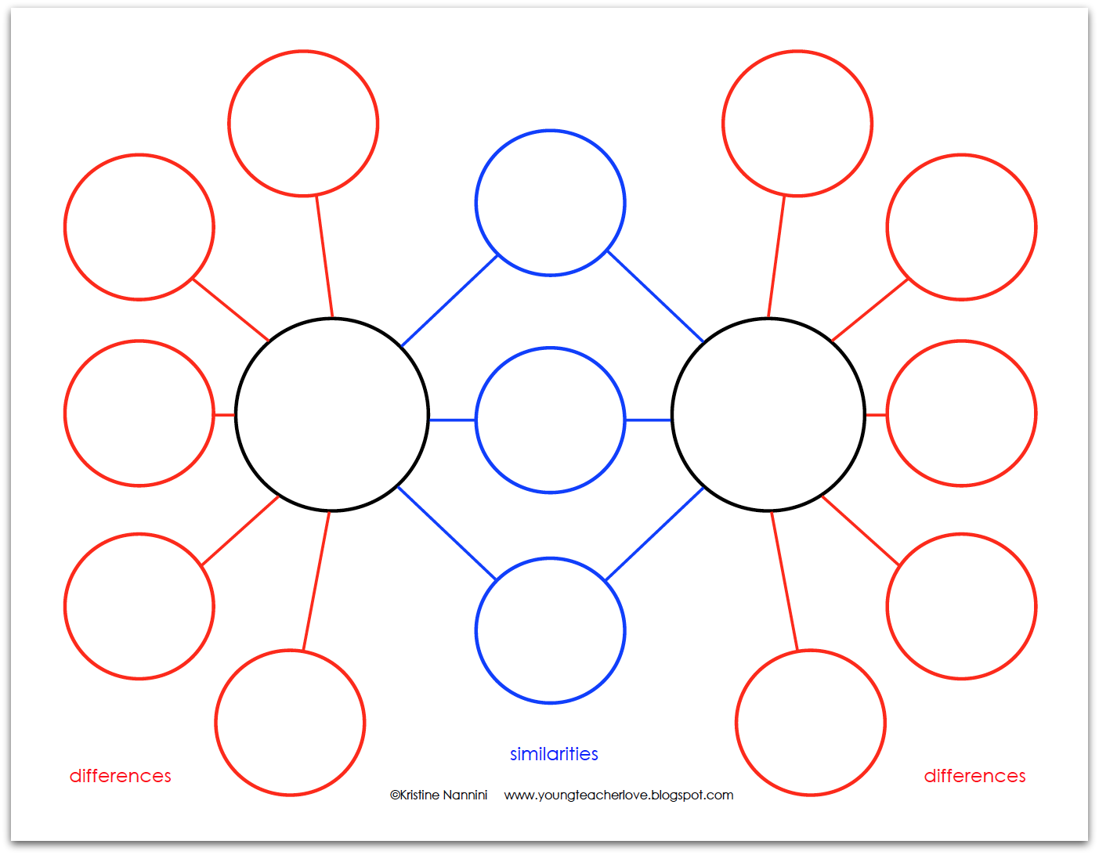
Treasure Island
Techniques to keep readers interested

Or – create a method that works for you!
Be prepared on August 14, 2017 to share your findings.

