SBAC Practice Test
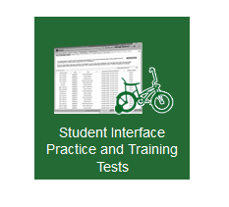
http://sbac.portal.airast.org/practice-test/
CLICK HERE PLEASE!
No Login Needed –
- Just click SIGN IN.
- CHOOSE appropriate grade (7) from drop-down box.
- CHOOSE either NO or YES for school – it doesn’t matter.
- CHOOSE this one – 1st one on the RIGHT side
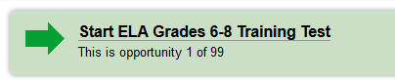
- CHOOSE SELECT at the bottom.
- CHOOSE YES, START MY TEST.
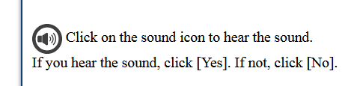
- CLICK on the speaker ICON.

- BEGIN TEST NOW!

To Do List March 3-4, 2015
1.WHAT Internet Search Engine did you use?
2.HOW did you follow the directions?
3.HOW do you use the GLOSSARY function?
4.HOW do you use the HIGHLIGHTING feature?
5.HOW do you use the NOTEPAD?
6.HOW do you make words/sections BIGGER?
7.HOW do you see the Video Tutorial?
8.HOW do you use the QUESTION DROP-DOWN List?
9. WHEN will you take the SBAC test for English?
10. WRITE one test strategy that you can use during SBAC testing.

